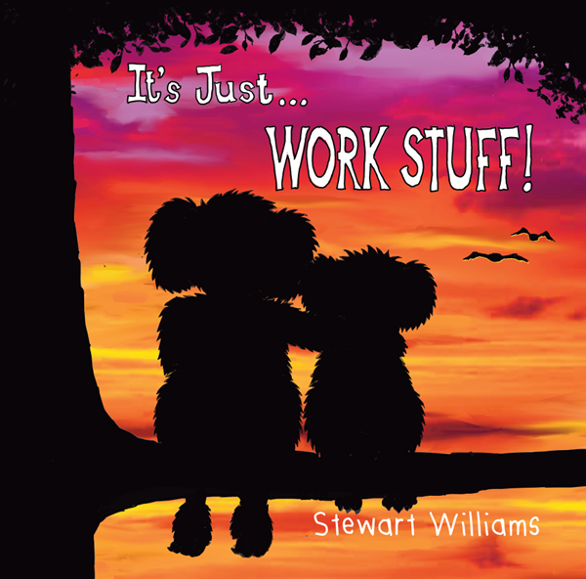
PRESENTING
‘It’s Just Work Stuff!’
A book created for children of front-line Emergency Services Workers whose parents are struggling with work stress or PTSD.
Written and illustrated by a serving police officer.

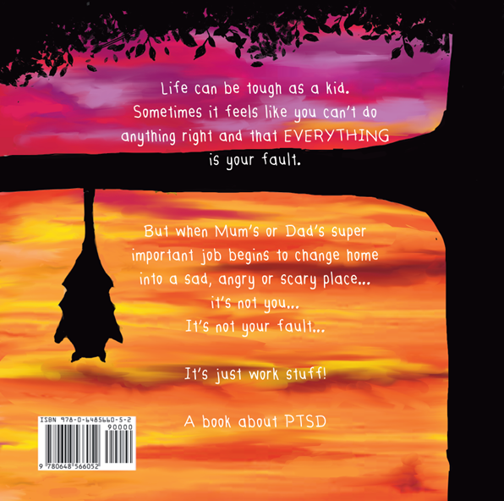

Please fill out the below and email to stewwriter@outlook.com.
I would like to order |  | copies @ $11 per copy
Please forward copies to the following address:
Please forward invoice to (email address, contact name and phone number please):
*Free Postage for orders over 100
For all other enquiries please email stewwriter@outlook.com

